Sudo systemctl status docker

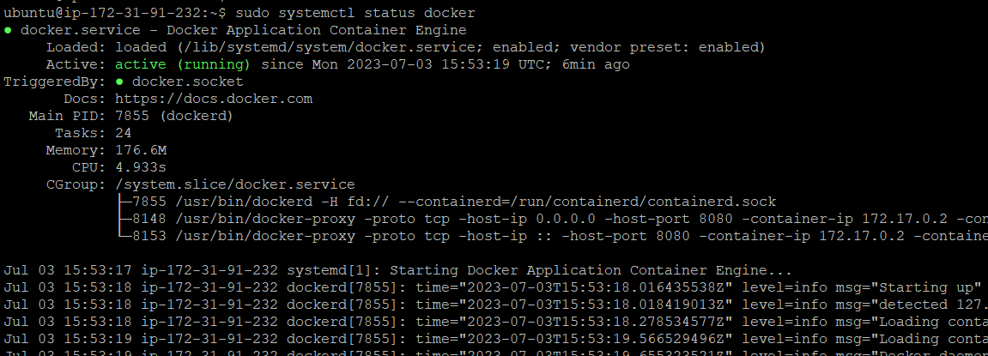

Sudo docker pull httpd

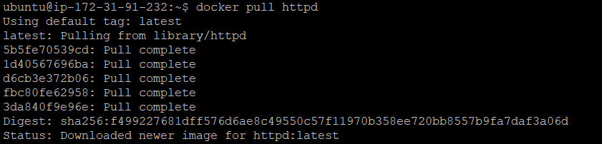

docker images  
 docker run -itd -p 8080:5000 <image_id>

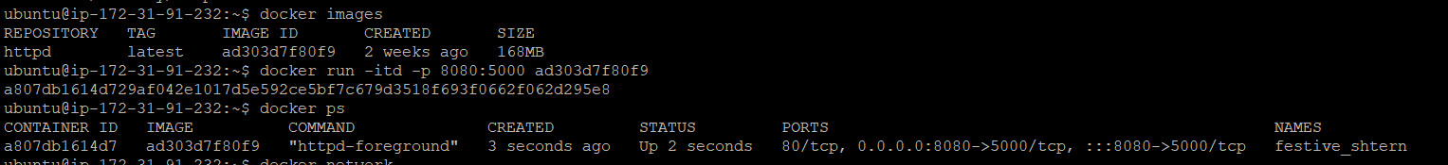

docker stats

